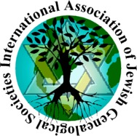 |  | International Association of  Jewish Genealogical Societies (IAJGS)  P.O. Box 1094, Agoura Hills, CA 91376  www.iajgs.org
August 3, 2003

The International Association of Jewish Genealogical Societies (IAJGS) is pleased to announce that Miriam Weiner has been named as its 2003 Lifetime Achievement Award winner. The award was presented to Ms. Weiner on July 24th in Washington, D.C., during the 23rd IAJGS International Conference on Jewish Genealogy, attended by more than 1,200 people from eighteen countries. Ms. Weiner has devoted her life and significant talent to identifying and researching resources for Jewish genealogical research. Miriam's negotiations and collaboration with archivists has yielded a trove of data about the location of, and access to, important records. She has selflessly shared her knowledge through lectures, articles, books, interviews and the Routes to Roots Foundation website, motivating countless people to research their Jewish ancestry.

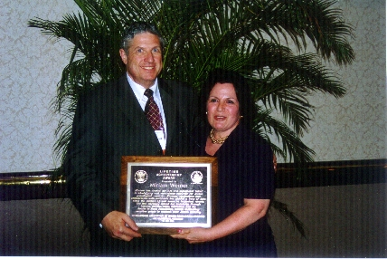
Miriam Weiner with IAJGS president, Hal Bookbinder

The IAJGS previously honored Ms. Weiner with awards for her two books: Jewish Roots in Poland and Jewish Roots in Ukraine and Moldova. Miriam is considered the pioneer in identifying, cataloging and publishing inventories of Jewish and civil records in Poland, Ukraine, Moldova, Belarus and Lithuania. In a 1991 interview, The Jewish Week (New York) referred to Miriam as “The Genealogist who Lifted the Archival Iron Curtain.” Ms. Weiner was the first Jewish genealogist certified by the Board for Certification of Genealogist in 1985. Previously, she wrote a syndicated column, “Roots and Branches” published in more than 100 Jewish newspapers and journals.

Through her company, Routes to Roots, Miriam has organized customized individual and family tours to the “old country” and through archive research, has discovered documents enabling people to trace their family history back into the 1700s. The Routes to Roots Foundation website at www.rtrfoundation.org features a searchable database of archive documents in the foregoing five countries, searchable by town name. In a 1998 interview, The Forward said: “When you want to go home to revisit the lost world of Jewish European life, whom are you going to call? Enter Miriam Weiner, the Indiana Jones of prewar Polish Jewry.”

The International Association of Jewish Genealogical Societies (IAJGS) includes 75 national and local societies on six continents, with 10,000+ individual members who are actively researching their Jewish roots. Annually, since 1998, it has recognized excellence in the field of Jewish genealogy through the presentation of outstanding achievement awards.

Hal Bookbinder, IAJGS President
Bookbinder1@earthlink.net

